COUNCILLORS PRESENT:
Cllrs. Lynne Grimshaw (Chair), Graeme Wright, Marjorie Chambers, John Tully, Caroline Ball, Sophie Robinson, Pauline Thompson, Matthew Cuthbert, Glyn Davies, Jim Lang, Paul Wright, Bob Walkinshaw, Mark Purvis, and Liam Lavery.

ALSO, IN ATTENDANCE
Sarah Eden – Executive Officer and Responsible Financial Officer, Stephen Humprey – Assets and Development Manager, Alan Bunker – Allotments Officer and Gary Holmes – Administration Assistant.

FGS24/143 WELCOME BY THE CHAIR
Welcome by the Chair Cllr Lynne Grimshaw.

FGS24/144 APOLOGIES FOR ABSENCE
Apologies for absence were received from Cllr Victor Bridges, Louis Brown, and Sophie Robinson.

FGS24/145 DISCLOSURE OF INTERESTS
Cllr Marjorie Chambers disclosed an interest for FGS24/157 ASHINGTON WORLD WAR II MEMORIAL ARBORETUM AND PLAQUE PROJECT as Chair of Ashington Branch of Royal British Legion.

FGS24/146 DISPENSATIONS
A dispensation was requested by Cllr Marjorie Chambers to speak on the project. The dispensation was AGREED.

FGS24/147 PUBLIC PARTICIPATION
There was one member of the public present, but not wishing to address the Council on any matter.

FGS24/148 MINUTES OF LAST MEETING
It was AGREED to RECEIVE and SIGN as a true record, the minutes of the meeting held on Tuesday 12th March 2024.

FGS24/149 CLERK AND OFFICER UPDATES
The following update was RECEIVED which had been sent out in advance of the meeting.

Regeneration Updates

Wansbeck Square/Grand Corner
Monday 22nd April – from 3:00pm site visit to Wansbeck Square then Grand Corner. Followed by meeting at Advance Northumberland.

Hirst Masterplan
Tuesday 23rd April – 6:00pm presentation in Town Hall, Chamber.

Ashington Market
Considering further concerns raised about the market, Sarah has contacted the NCC Markets Manager highlighting the general concerns.
“Councillors have periodically raised concerns about the appearance of the market, such as inconsistent stall designs, stalls encroaching beyond their designated areas, van doors being left open, and traders occupying parking bays. While these may not be concerns for traders or market visitors, they continue to be raised, and it would be beneficial to address them.
Considering these issues, would you welcome the opportunity to speak with the Town Council about the market's status, any forward plans, and improvements? This would provide an opportunity to listen to Councillors' concerns and work towards finding mutually agreeable solutions.”

Following the question being raised, the Executive Officer responded that no response had been received from the Markets Mgr regarding a meeting.

Allotments (Capital Works)
Woodhorn roadways, due to the inclement weather the start of the road works has been delayed. Alan has contacted the contractor D.A Johnstone, possible further delays this week and snow forecast for W/C 8th April 24.

Allotments (General)
Volunteers at North Seaton Colliery have achieved some great improvements, creating a small area for up to 4/5 vehicles. One outstanding tenancy agreement for North Seaton Colliery, this is a new tenant on the site. Less than 20 outstanding agreements for Hirst East End.
Nursery Park have recently received their invoice for the new financial year with 38% already paid. We are looking at improving security at Nursery Park, which has been deferred for several years. Costs are being sought for a new fence and gate. Our second allotment week is scheduled for the second week of June.

Ashington Town Centre CCTV
Preparatory works, by our contractors Asset Watch are continuing for the new town centre CCTV system and subject to the installation of power supply by NCC, will be online within coming days. Eleven cameras in total will be installed with images sent via equipment on the Town Hall roof to Asset Watch’s premises on Jubilee Industrial Estate. All images from the system will be readily available to Northumbria Police.

In response to a question about the higher costs for commando sockets, the Assets and Development Mgr confirmed that the Council had achieved these at less expense from NCC.

Following a question about publicity for the CCTV scheme, it was confirmed that once the system was up and running in full, a press release would be put out.

ATC Neighbourhood Services
Work is on-going in replenishing shrubbery in town centre and entrance feature planting in preparation for the summer season. Planting enhancement works have also taken place around the Jack Charlton statue with on-going maintenance work now the responsibility of the Town Council.

The removal of winter planting in the town’s flower towers and troughs will take place in the coming weeks in preparation of summer planting due to be installed in mid - late May. We have asked Wansbeck Garden Centre, who provide the flower tower planting for more emphasis on sustainable planting.

Work is planned for the painting of public seats around the town with the initial focus on public seats in the bus interchange area.

Three bus shelters in the Seaton Ward (close to the NCEA) will also be repainted in coming weeks following on-going graffiti issues.

Removal of Town Council signage has taken place at Shire Farm and Warren Court Play Areas.

Tree Planting
The Northumberland County Council tree planting schemes carried out in the Haydon ward were completed w/c 8 April and we would welcome your thoughts.

Events and Engagement

Youth Support Wellbeing Coffee Morning
Sharon attended the coffee morning on Wednesday 13th March at the Hirst Welfare. A networking event focused on youth support arranged by Wansbeck Community Links. Some of the organisations in attendance included, Northumberland YMCA, Northumberland Recovery College, Thriving Together and Morpeth Vision Impaired Group.

Work Experience
Maddie is enjoying the work experience and has done an excellent job of designing the Easter Trail poster and sticker card as well as taking part in the litter pick arranged for the Hirst Area.

Bunny Hop Easter Egg Hunt
Families were invited to join in the fun this Easter with the return of The Bunny Hop Easter Trail. Beginning Saturday 23rd March kids can search for a special Easter egg posters at participating shops around the town, in addition to the high street, Milburn Road and Hawthorn Road are also included.
Initial feedback from traders is positive with a couple asking for more sticker cards. (each shop had received 20 sticker cards). Certificate and Easter egg presentations to take place on Friday 12th April and Saturday 13th April at Ashington Library in the Leisure Centre.

Climate Action Poster Competition
An invitation letter to take part in ATC’s Climate Action Poster Competition went out on Thursday 28th March to Ashington Academy, Ashdale, Bothal Primary Upper Site, Castle School, Central Primary Upper Site, Dukes Secondary School, and St Aidens R.C. Primary School.
Four schools have already confirmed they would like to take part. It is hoped that all schools will confirm by 20th of April, allowing the launch date to coincide with World Earth Day on Monday 22nd April.
Great British Spring Clean
A successful week of litter picks, with nearly 30 volunteers involved, some from Ashington Community Litter Project, Northumberland Rivers Trust, Heart of the Hirst Residents & Tenants group, North Seaton Colliery Community Centre, North Seaton Community Centre, asylum seekers living in Ashington and children from Castle School. Cllrs. Caroline Ball and Jim Lang also help on Easter Saturday at Paddock Wood.
Approximately 100 bags of litter were collected over the four days. Northumberland County Council Neighbourhood Service Team picked up the bags after each litter pick.
See link below for ATC website news article.
Hirst Working Group Meeting Summary
Sharon attended a Hirst Working Group meeting on Wednesday 3rd April at Hirst Welfare.
Northumberland Communities Together providing updates on a new directory and employability initiatives with NCVA next week.
Tensions remain high in the community around population shifts. Residents encouraged to direct concerns to Wayne Daniels at Northumbria Police. Police still facing challenges engaging asylum seekers.
Ashington Hirst Welfare received Youth Investment Fund for renovations including redesigned reception areas, new window shutters, and developing a youth work program. Construction to begin soon.
The Welfare are withdrawing application to Leisure Partnership fund to instead apply for CCTV due to increasing anti-social behaviour and property damage on grounds.
Hirst Park Play zone project awaiting start date.
Ashington Family Hub launching new Dad's Saturday programs in Ashington and Bedlington, expanding after school club with prevention/intervention work. Online sessions and graffiti wall coming soon.
Newcastle United Foundation setting strategic goals to extend reach in Northumberland, launching Ashington Connected with on-site staff at Welfare for employability skills. Bringing walking football, careers work.
Wansbeck Square regeneration to include community space. Public engagement sessions planned, designs to be completed by July 2024.

Northumberland Miners Picnic
Rowan responded very positively to thank the Council for their continued support. Woodhorn Museum are working with Walk the Plank to assess the relaunched 'Animating Astington' tender. If successful, they advise it will facilitate better cultural connectivity between the Town and the Museum and provide some useful learning for future events.

Detached Youth Group
A first meeting needs to be arranged. There is a feeling that the Council should lead on a collaboration meeting to bring together youth groups working in Ashington. This will be brought forward as a proposal when further information can be gleaned about meetings already being held in the town of a similar nature.

Potland Burn
19/03/2024 Further update received from Countryside Officer:
An update of the reinstatement of the public rights of way on the Potland Burn ex open cast site. I have been in touch with the land agent acting on behalf of Advance Northumberland for the restoration of the site.
I conducted a site visit on the 7th of February with James to identify the progress that is being made on the site. The site visit showed that some progress has been made to reopen however, there is still a way to go before we can reach the order making stage and formally create the proposed rights of way network.
After this site meeting, I have provided a work advice schedule to James identifying the works required to be carried out to reopen the original right of way network on the park before it became an open cast site. Currently as it stands footpath 600/003 is clear and available for use. Footpath 410/007, 600/004 work has been identified along the route as this is proposed to be upgraded to bridleway, this is currently functional as a footpath.
Work is still required at 600/097 at the Ashington bridleway and has been addressed in the work schedule, this would open a direct route from Ashington up to Longhirst and would tie in with 410/007 and 600/004.
Footpath 600/006 was discussed about potentially being diverted to tie in with the current line of 600/097. This was to avoid a large wetland area on the footpaths current route. No work has been discussed about this yet.
I have requested a follow up meeting to discuss progress at the site for the end of May/ early June.
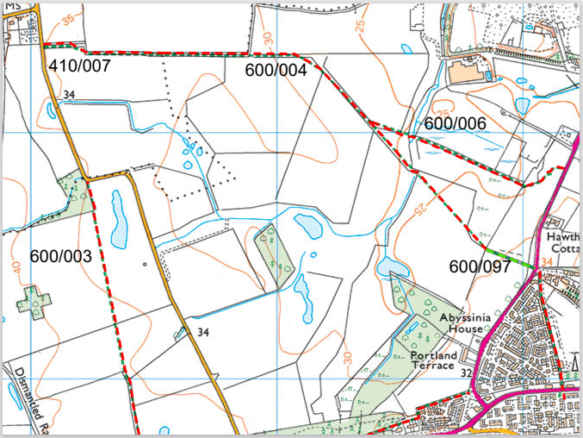

News Items (with links)

Stress Awareness Month - April 2024

Ashington Community Unites for Successful Great British Spring Clean

Ashington's Civic Head Witnesses Homecoming of HMS Blyth's Historic Bell

Hop to It! Ashington Town Council Launches Bunny Hop Easter Trail

Northumberland County Council to Submit Demolition Application for Wansbeck Square

Action For Insects How To Build A Hedgehog Home

Action for Insects Build A Hedgehog Hole

Casual Vacancy - College Ward

Build a Bat Box for Action for Insects

Ashington Town Council Annual Grant Aid Now Open For Applications

Town Council Approves Funding, Launches Annual Grants Program, Welcomes New Councillor

Ashington Gets Buzzing for Insects!

Top post for engagement – commented upon, reacted, shared, or clicked.
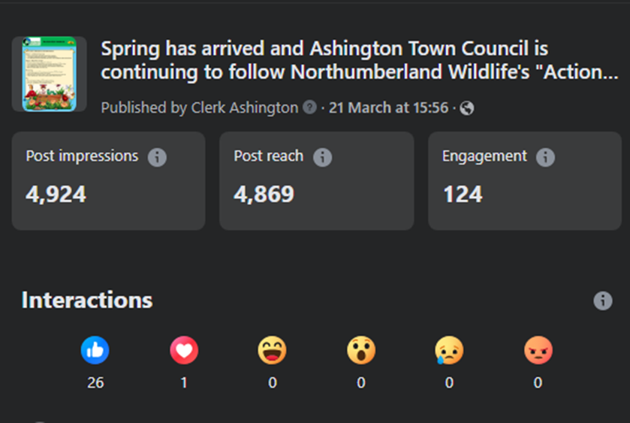

Facebook Page Overview
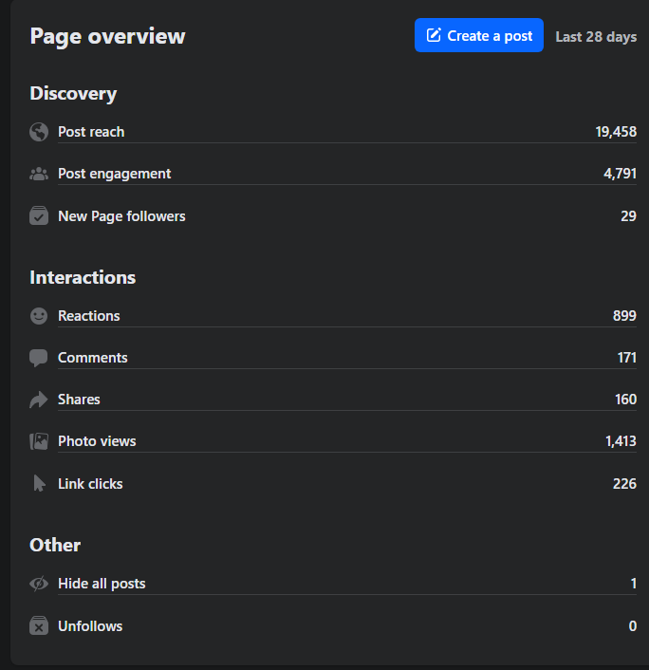

Top Post for Reach – how many people saw it.

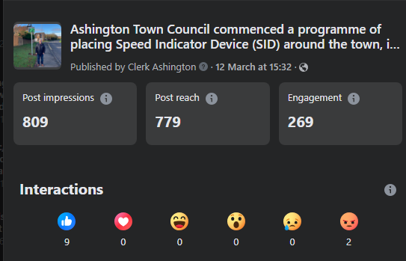

FGS24/150 BUDGET AND EXPENDITURE 2023/24

Updated Budget Report
It was AGREED to RECEIVE the updated budget report and direct any questions to the Responsible Financial Officer (RFO). There were no questions directed to the Responsible Financial Officer (RFO).

Accounts Paid and to be Paid (including Bank Reconciliation)
It was AGREED to RECEIVE a schedule of accounts paid and to be paid; to ENDORSE those accounts paid, and AGREE those to be paid, since 3rd March 2024.

Year Ending 31st March 2024 Bank Reconciliation
It was AGREED to RECEIVE the year-end bank reconciliation, noting that it would be presented again to Full Council in June, alongside the completed Annual Governance and Accountability Return (AGAR).

2024/25 Budget and Expenditure
Following completion of the year end reconciliation, to restate financial position based on the agreed 2024/25 budget, and carried forward commitments, noting the small surplus. It was AGREED that this surplus is moved to Allotments (General) to support the ongoing jobs being worked through.

Cllrs Tully and Ball expressed concern regarding spending on allotments. The RFO responded that the budget for allotments has been reduced in the current financial year, but the Council should be mindful that allotments were one of the Council’s largest assets, and as a result the greatest liability in regards spending. Noting that there would always be roads and boundaries to maintain, and asbestos to deal with appropriately.

In response to questions the RFO advised that there was little the Council could do about escalating costs, but more should be done to reduce the difference between income and expenditure, which meant looking at rents with this income going directly into allotments, rather than being funded largely by the precept.

FGS24/151 DRAFT REPORT OF ENHANCED NEIGHBOURHOOD SERVICES PARTNERSHIP BOARD MEETING
It was AGREED to RECEIVE a report of the meeting held on 19th March 2024.

Cllr Tully reminded the meeting that NCC would be looking at Grounds Maintenance, and reviewing their service offerings to ensure they can continue meeting the community's needs. Cllr Tully expressed that the community needed to be taken along with the sustainability message to avoid the opinion that changes are driven by financial considerations rather than a desire to enhance and sustain services for the Town. Cllr Ball added that any financial savings made on the back of sustainability should come back into the town.

Cllr Glyn Davis reminded members that concerns regarding delivery under the agreement should be brought to the attention of the Executive Officer, or members of the Partnership Board.

Cllr Ball asked if a question could be taken back on Core Service delivery under grass cutting, and what work was carried out during the period when grass cutting was delayed due to weather.

The Executive Officer advised that the result of the Council’s reduced commitment to the Partnership had resulted in five operatives, rather than six, which would be discussed as an agenda item at the next Partnership meeting. The Local Services Mgr confirmed that this resulted in a surplus that could be used to fund a seasonal worker, or the additional funds over and above five operatives could be used elsewhere by the Town Council, or not paid over. This would be brought to the June Partnership meeting for discussion, and any recommended decision brought back to the Finance and General Services Committee.

FGS24/152 REPLACEMENT BUS SHELTERS
It was AGREED to RECEIVE quotations from the Council’s preferred and sole supplier of chosen style bus shelter for the locations below, and agree to place order totalling the funds available, with additional funding from County Cllr Lynne Grimshaw’s Capital Small Schemes Fund.

High Market (north side) £7,078.25
High Market (south side) £7,667.25
A1068 Portland Terrace (West) £9,196.25
A1068 Opp. Portland Terrace (East) £9,417.25 (funded by County Cllr Lynne Grimshaw)
Following a question about window materials, the Assets and Development Mgr confirmed that alternative materials had been sourced for the bus shelters, as the previously used Perspex and plastic were not ideal in some places, they would be glazed or mesh. .

FGS24/153 PLAY AREAS

Epsom, Aintree, and Seaton Vale
It was AGREED to RECEIVE formal update that these play areas have been legally transferred to Ashington Town Council, and registration of title deeds are being processed.

Warren Court and Shire Farm Close
It was AGREED to RECEIVE formal update that the Council’s caretaking of these play areas has officially ceased.

Alexandra Road, People’s Park, North Seaton Colliery, Paddock Wood
It was AGREED to RECEIVE 25-year ‘Draft Heads of Terms’ Lease from Northumberland County Council, and RFO notes.

It was AGREED to write to the portfolio holder with responsibility for Play Areas, and the Leader of NCC to ask that the decision to recharge Ashington Town Council for £2,800 costs incurred in the legally required advertising of the disposal of assets is revisited.

FGS24/154 DETACHED YOUTH WORK

Report of meeting held on 19th March, and work delivered to date
It was AGREED to RECEIVE a report of the liaison meeting held on 19th March, which was the final meeting due to the end of the one-year agreement.

Cost of delivery
It was AGREED to pay the invoice for detached youth work delivered in quarter four, December through to March.

FGS24/155 YOUTH COLLABORATION MEETING
It was AGREED to repurpose the previously agreed Detached Youth Work Group, under the new arrangement to seek collaboration among youth providers, as well as the aim of establishing a Youth Forum.

It was AGREED that Ashington Town Council should lead the collaboration efforts. It was AGREED that Cllr Caroline Ball would Chair the meetings, with Cllrs Louis Brown, Matthew Cuthbert, Lynne Grimshaw, and Graeme Wright.

FGS24/156 SKATE PARK PROJECT
It was AGREED to delegate to the Assets and Development Manager to undertake a feasibility study for a new skate park at People’s Park, including consultation with potential user groups, location, design, and costs, and the availability of external funding.

The involvement of young people in consultation was discussed as being key to the project. It was discussed that the Council could potentially hold an event with sponsorship and competitions.

FGS24/157 ASHINGTON WORLD WAR II MEMORIAL ARBORETUM AND PLAQUE PROJECT
It was AGREED to SUPPORT the project proposal and the Council’s involvement.
- Allocation of staff resources to assist in project coordination, funding efforts, liaison with stakeholders, and overall project management.
- Consideration of financial contribution, via NSO’s to support tree maintenance, plaque production, and installation.
- Provision of guidance and access to relevant historical records to ensure accuracy in the plaque inscriptions.
In response to concerns raised about the location of the project and the maintenance of the trees over the years once completed, the Assets and Development Mgr responded that this was where the trees were originally planted, in regards maintenance this would be the Cricket Club as their land under lease.
It was suggested that if businesses within the Town may be interested in supporting the project, the Assets and Facilities Mgr confirmed that the Chair of Ashington Cricket Club was well connected and would be seeking support.
In terms of time as a resource, as the project was in its infancy this would become clearer as planning progresses, but the Council is expected to support, not lead.

FGS24/158 CASUAL VACANCY – COLLEGE WARD
It was AGREED to RECEIVE notice from the Elections Office that no request for an election has been received.

Co-option Procedure
It was AGREED to APPROVE the co-option procedure to be followed, and the eligibility form interested candidates must declare.

Co-option Advertisement
It was AGREED to endorse that the advertisement declaring that the Council can fill the seat by co-option is duly made, and the meeting on which the matter will be placed is confirmed as the Full Council meeting on 28th May 2024.

FGS24/159 EXCLUSION OF PRESS AND PUBLIC
The press and public were not excluded.

FGS24/160 CONFIDENTIAL ITEM
The confidential item was withdrawn.

FGS24/161 DATE, TIME, AND VENUE FOR THE NEXT MEETING
Tuesday 14th May 2024, 6:00pm, Council Chamber.
Meeting ended 19.30pm

